Launch Linux EC2 instances in two regions using a single Terraform file.

**main.tf file**

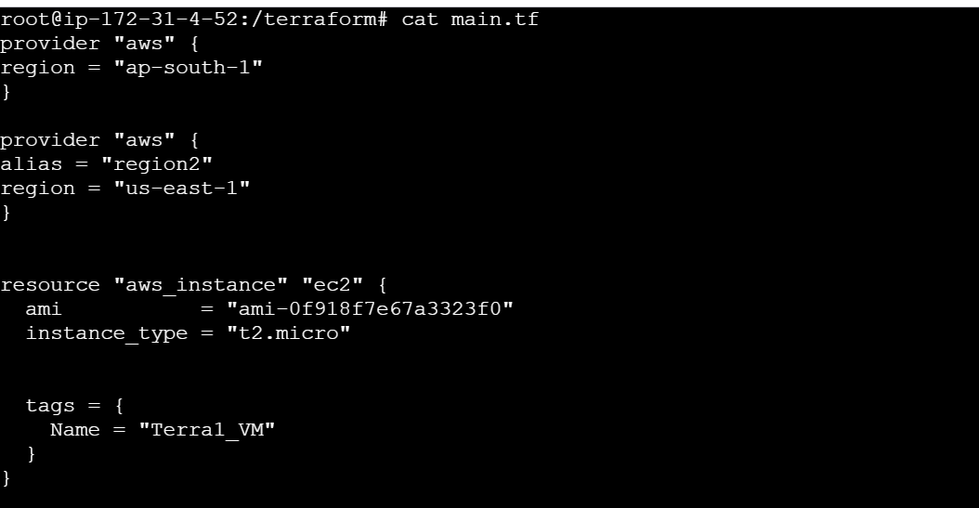

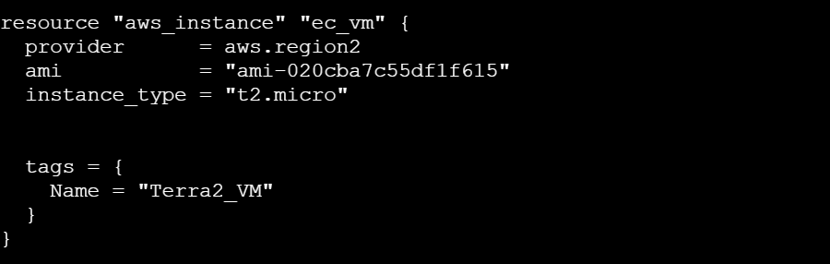

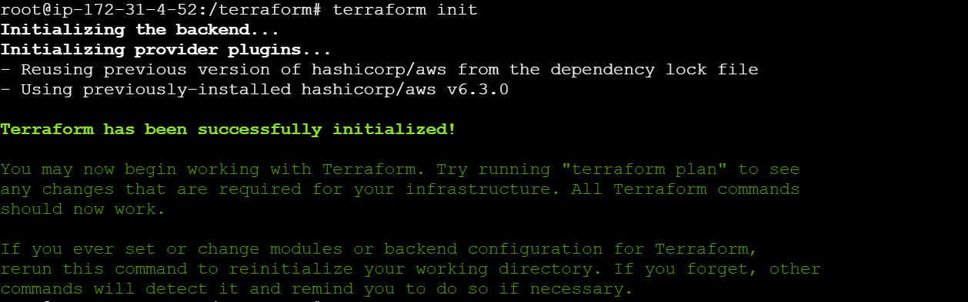

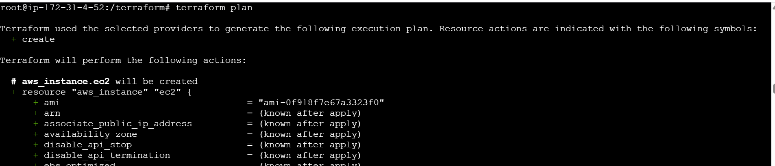

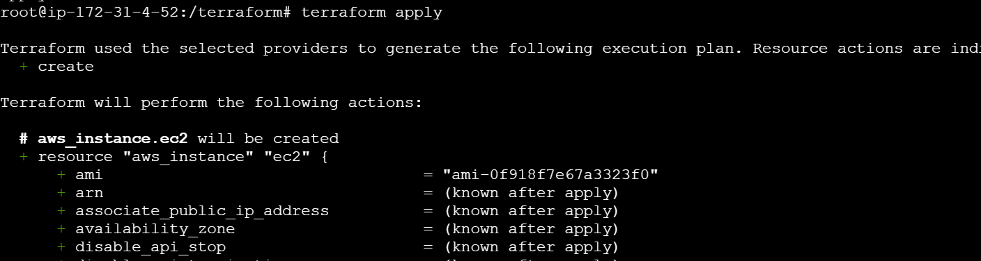

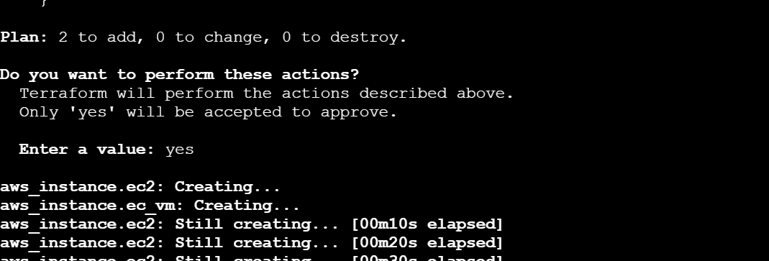

**VM in ap-south-1**

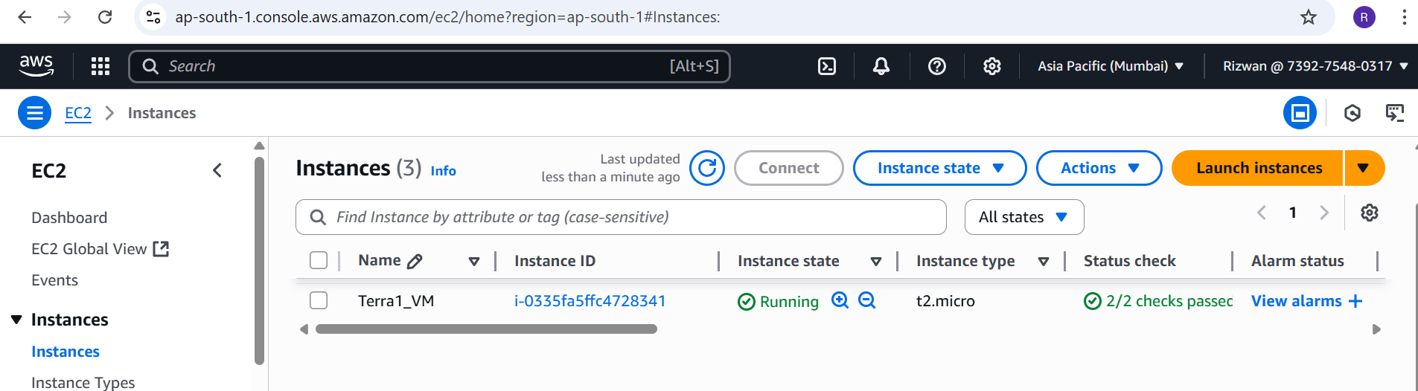

**VM in us-east-1**

